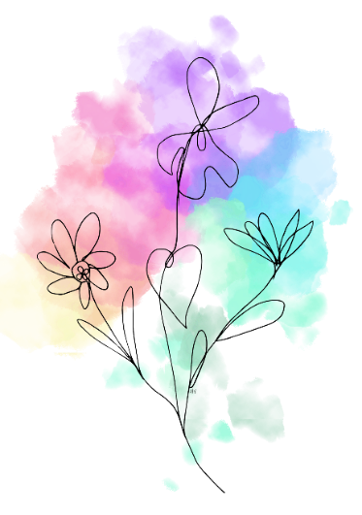
Growing Wildflowers
Scholarship Application: Terms and Conditions

Section A: Individual Scholarship Applicant Conditions
All of the following criteria must be met for scholarship eligibility:
- Resident of the Commonwealth of Pennsylvania.
- Meets the criteria of medically complex, as defined below:
  - An individual with one or more chronic conditions that cause severe functional limitations and require extensive medical support and/or assistance.
Section B: Facility Scholarship Applicant Conditions
All of the following criteria must be met for scholarship eligibility:
- Facility has an established residency within the Commonwealth of Pennsylvania.
- Facility serves children and their families within a community.
- Facility is able/willing to provide services to children with complex medical needs.

Section C: Scholarship Limitations
- Individuals and facilities will only be awarded 1 scholarship within a 6-month period.
- Individual Scholarship life-long cap: $10,000
- Facility Scholarship life-long cap: $15,000
- Applications status shall not be impacted on the basis of race, color, religion (creed), gender, gender expression, age, national origin (ancestry), disability, marital status, sexual orientation, or military status.

Section D: Scholarship Terms
- Only completed scholarship applications will be reviewed.
- Applications that do not meet with above criteria will be denied.
- Scholarship applications can be denied by the Board of Directors for reasons that do not require disclosure.
- Applications will receive a “Notice of Receipt” when completed applications are received and enter review process.
- Applications will be reviewed by the Board of Directors and a determination will be made within 30 days of “Notice of Receipt”.
- Scholarship determination will be classified as one of the following categories:
  - Approved
  - Approved with Revisions
  - Denied
- Applications that are classified as “Approved with Revisions” will have 30 days to submit requested revisions for potential approval.
